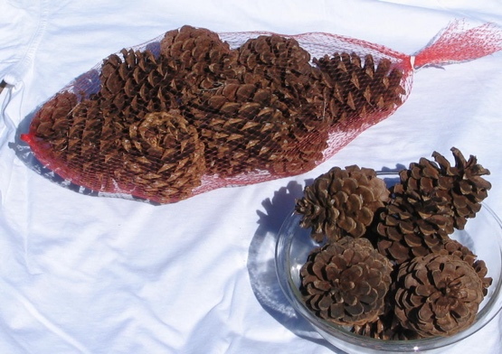

**Willamette Evergreen Inc.**

Ed Hallett

[Ed@WillametteEvergreen.com](mailto:Ed@WillametteEvergreen.com)

production – Molalla Oregon

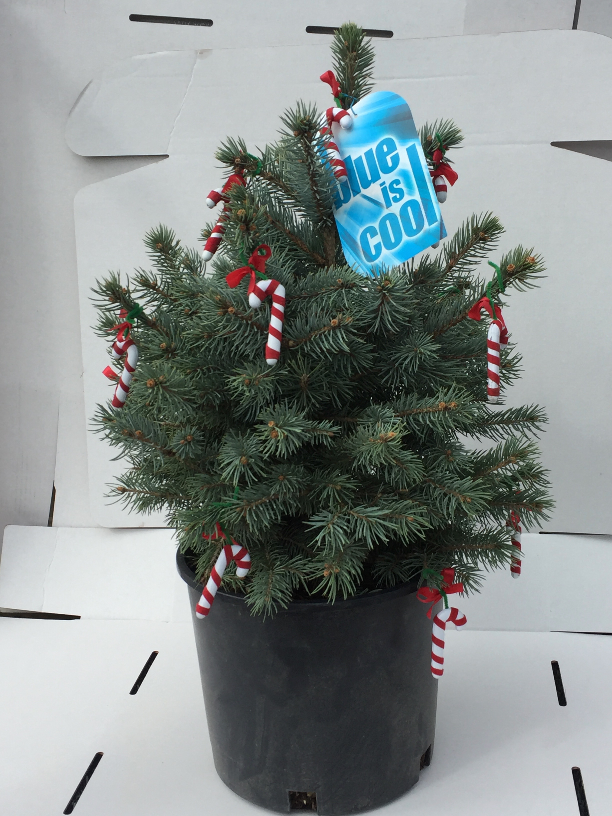

Scented Pinecones

Christmas Swag w/ Deluxe Bow 22”

Tabletop Christmas Tree

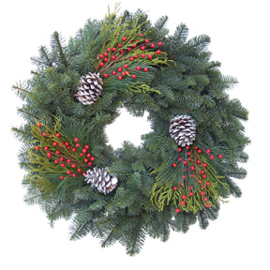

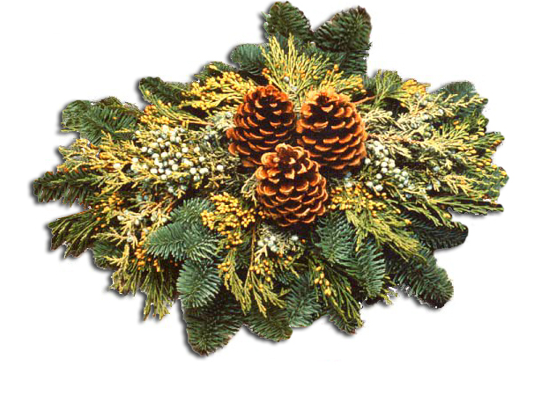

Winter evergreens carry a message that is understood by all –

**“Welcome Home”**

Christmas Swag w/ Deluxe Bow 22”

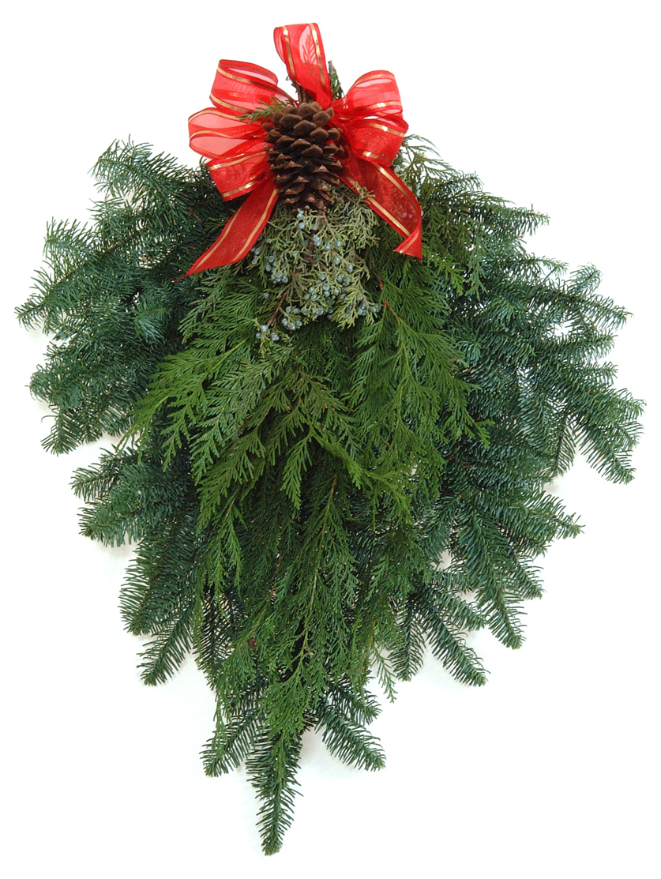

Evergreen Bouquet (ex vase)



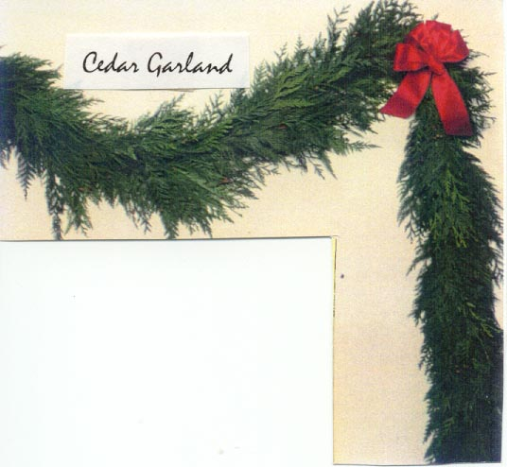

Oregon (Natural)

Table decorations

Wintercone & Candle

w/ candle included

Wintry Mountain.

&

Traditional Mixed Wreath



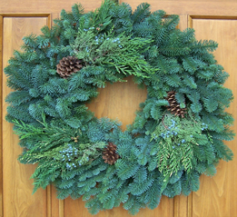

Winter Gifts From Snow Mountain

Here the evergreen air is clean and crisp

Snowy Mountain regal in tunic splendor guarded

By craggy fir sentinels

A cool white blanket of groundcover and cobalt blue sky

Shelter young conifers as a doe and her fawns

Pass effortlessly down the lake path.

Such a peaceful playground. We are warming

To the musical beat of a crackling fire conjuring up what

Winter gifts shall we bring into our home and

Send to our friends that

Bottle this spirit?



