

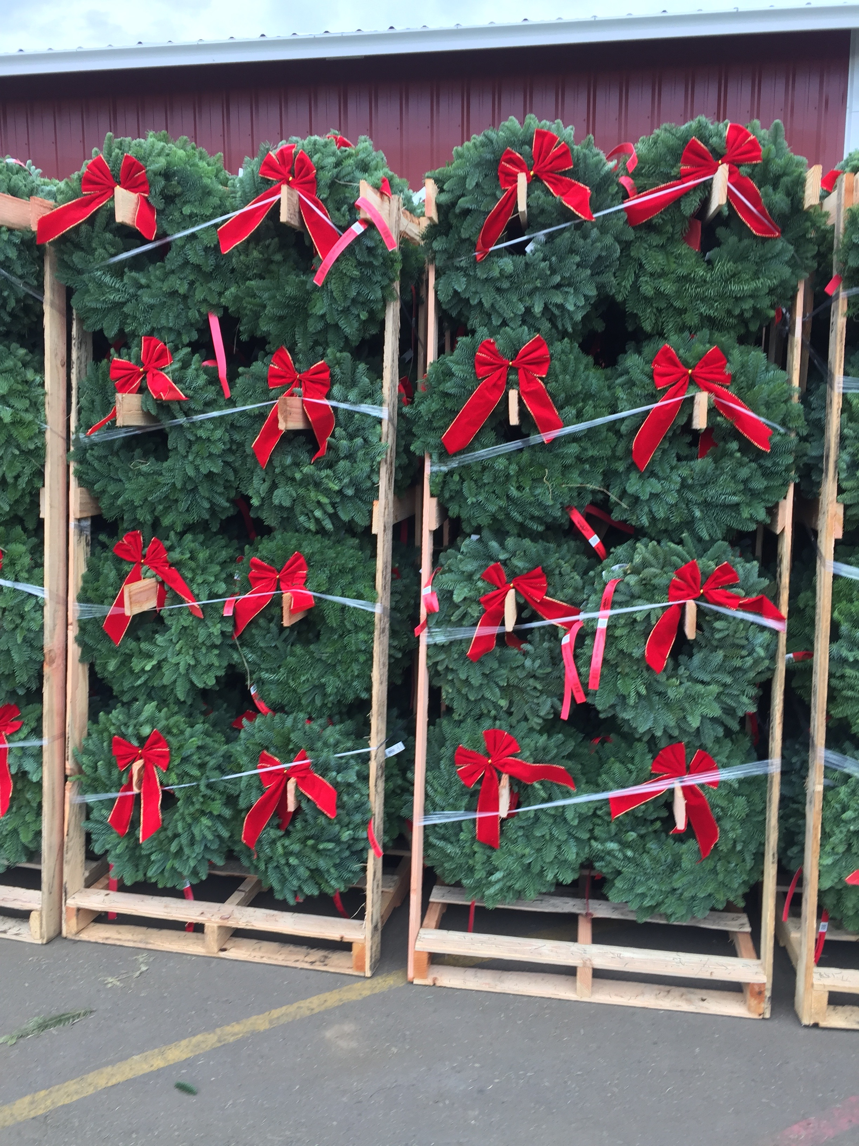

Traditional Wreath

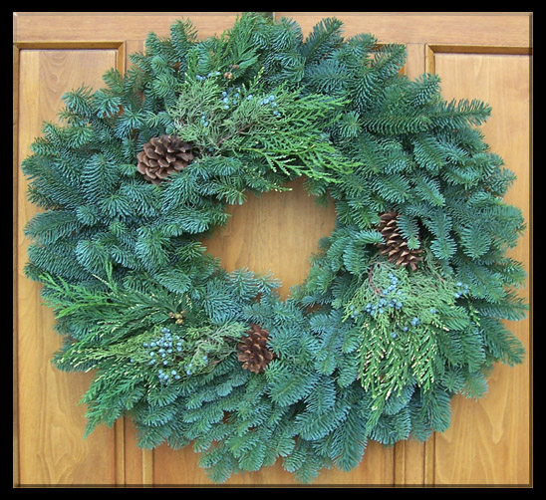

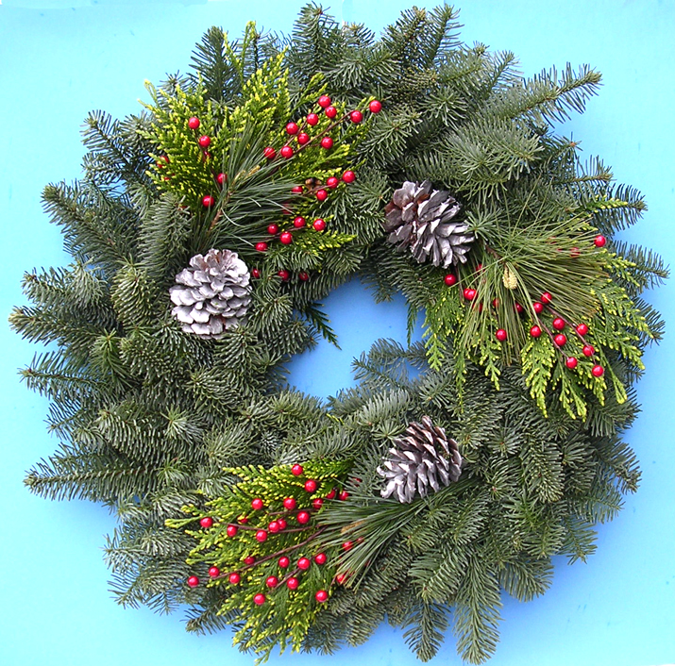
Wint’ry Mountain Wreath
Noble Fir, Cedar, Silver Cones & Red Berries
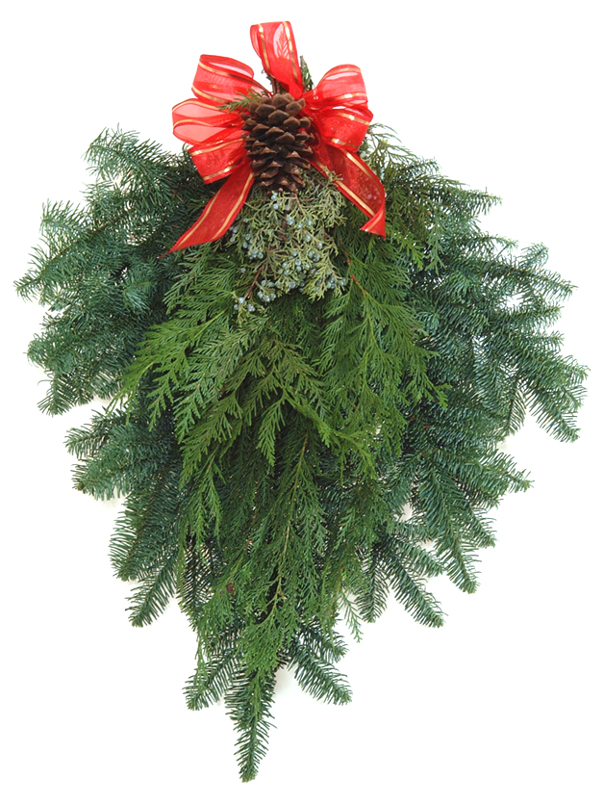
Traditional Swag
Noble Fir, Cedar, Blue-berried Juniper, Pinecone & handmade bow
Noble Wreath w/ Bow

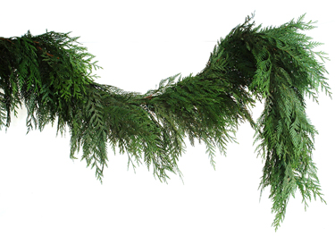
Fresh Cedar Garland

The urge to decorate with wreaths and other winter evergreens is a custom going back 2,000 years
They help us to slow down to enjoy the season! Ed@WillametteEvergreen.com; www.WillametteEvergreen.com

We also make Noble fir & Mixed Noble fir garlands

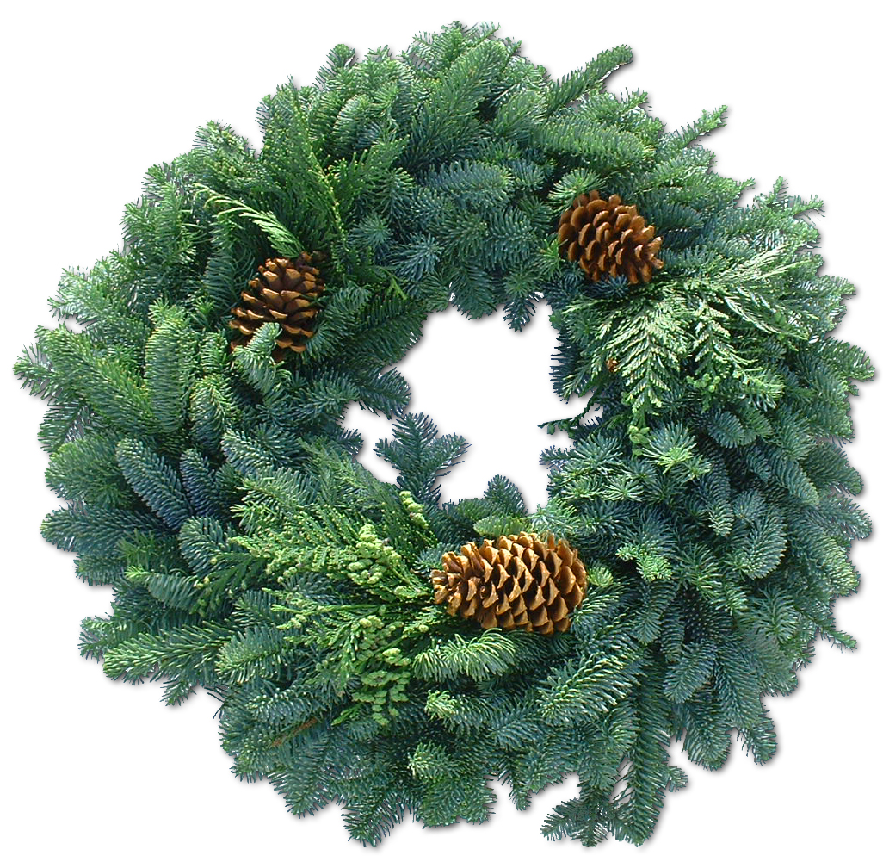
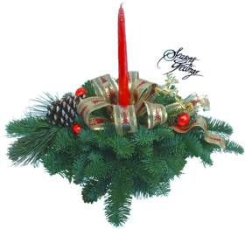
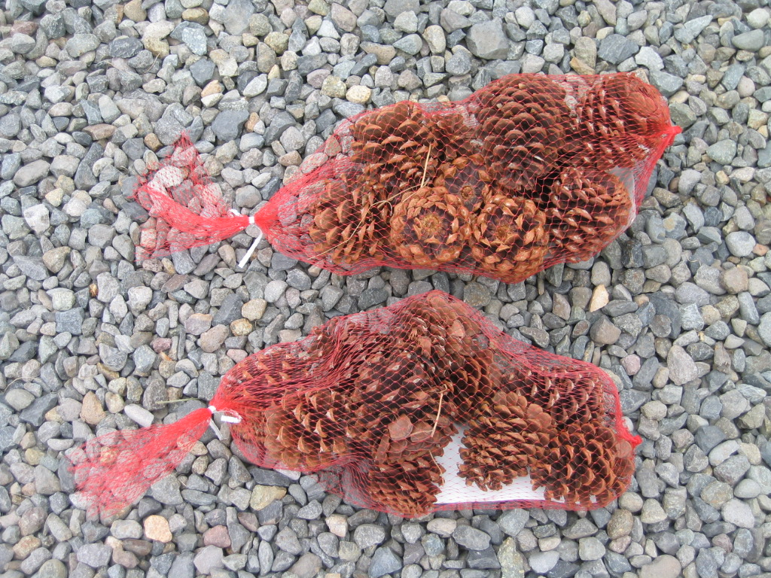
Noble Fir & Pine Cones
Wintercone & Candle Centerpiece
Noble Fir, Princess Pine, Handmade bow, Silver cones
I also come
Unfinished so
You florists
Can make your
Arrangements
- faster!

We make in
Baskets and Dishes

Your customers come to you looking for gift-giving and decorating ideas. Here is how we can help you help them – Winter Gifts

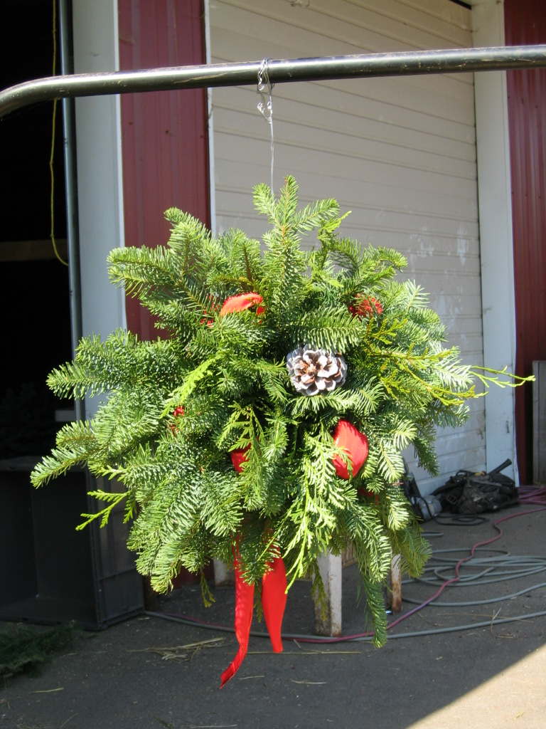
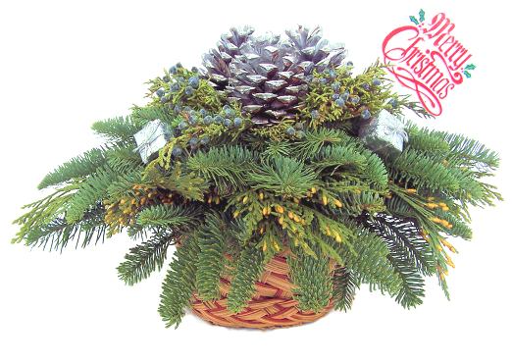
Family-Christmas Silver Centerpiece
Silver pinecones and silver giftpacks
On a bed of Noble fir, Blueberried juniper and Incense cedar
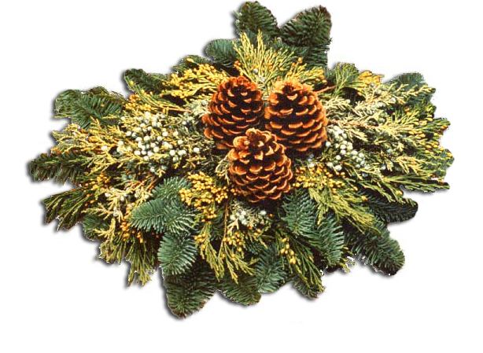

Blue spruce ‘Baby Blue’
Grows into a nice garden plant.
We pack in
bundles & cases display cases.
We also pack on Wreath/ Garland Racks.

Natural-Christmas Centerpiece
Pinecones

Kissing Ball


